**Mini Project Report**

**Under Supervision of:**

Mrs.Ganga Bhavani

**Submitted by**

A.V.L.G.Sandeep (18221A0507)

BVC Engineering College, Odalarevu

College Bus Info System

August - 2019

Department of Computer Science and Engineering

**Abstract:** It is very important to any College or School Management to maintain different data of Students. When coming to the college Transport system, this College Bus Info System can help to store number of student records with the related information like, place they are coming from, and bus they are boarding etc.

This is basically developed as a console application and any database is not connected with it. With this console application, a good number of student records can be stored and the data can be retrieved in desired format.

Meanwhile in the developing phase, A database and file concepts can be added to maintain huge data.

**Project Title:** College Bus Info System

**Objectives:**

1. To get desired data from raw information
2. To maintain college bus records

**Platform:**

**Operating System**: Windows

**Project Type**:

Console Application

**Programming Language Used:**

C++

**Keywords:** College Bus Info System, Array of Objects, Console Application,

Contents

**ABSTRACT2**

**CONTENTS3**

**INTRODUCTION**

Overview4

Purpose and Objective5

**DESIGN**

System Design6

Specification7-9

**TESTING AND ANALYSIS**

Test Results10-13

**FUTURE WORK**14

**REFERENCES**15

**Overview**

Introduction

This report discusses the result of work done in the development of “College Bus Info System” on C++ Platform. This project aims at the development of a simple console application for providing the required information from the raw data provided. Although this work can be done on paper records, it is not suitable for in the present day scenario. The Administration of the college should have the access to get the required details regarding students transport details. Since it is tedious to maintain paper records for all the college students, this approach will surely help in reducing the paper work in this world of Automation and facilitates the process of retrieving required information

**A. PURPOSE:**

The purpose is to design a console application that allows to add the student transport records and to retrieve required information.

**B. OBJECTIVES:**

* Providing interface to administration
* Reduce the burden of paper records system
* Decrease the time required to access the information

**SYSTEM DESIGN**

This deals with data flow diagram, and detailed design process of the front and back end design of “College Bus Info System”

**DATA FLOW DIAGRAM (DFD):**

A DFD is commonly used during problem analysis. It represents the flow of data from a system. Flow of data from different processes in the system are shown in the following Data Flow Diagram

**HOME:** This is the first screen a user can see. Here the different functionalities of this project can be visible in a form of list. A user can choose his own selection as per his requirement.

**ADD RECORDS:** This is a part where user can enter the student transport records to store them. User is asked about the number of records he is wishing to add, and then user can enter the details of that particular record.

**SHOW ALL RECORDS:** This section displays all the records that user entered. The format of the displaying records is as mentioned below:

**Roll Name From-Village Bus Number**

**Search by Village:** Search by Village Option allows user to find the students coming from a certain village, he entered. The village that user enters will be checked in the record details and outputs the student details coming from that village. The format of displaying Student details from a village is as mentioned below:

**Roll Name Bus Number**

**Search by roll:** This option allows user to enter the roll number of a certain student for which he need to find the transport details. That roll number will be checked in the record details and outputs the Transport details of that certain student. The format of displaying Transport details of a student is as mentioned below:

**Name From-Village Bus Number**

**Search by Bus Number:** This option allows the user to get details of students utilizing a certain bus. User need to enter the bus number. That will be checked in the record details and outputs the Student details from that bus. The format of displaying output of this section is as mentioned below:

**Roll Name From-Village**

**Student Count from a village:** This section gives the total count of students from a certain village. User needs to enter the Village name that will be checked in the record details. It outputs the total count of students from that village

**Student Count of a Bus:** This option gives the total count of students from a certain bus. User needs to enter the bus number that will be checked in the record details. It outputs the total count of students from that bus.

**DEVELOPMENT**

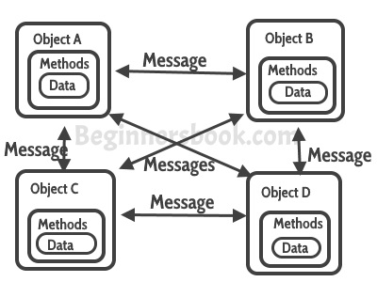The whole project relies on the concept of **Array of Objects.** Since the platform used to develop this application (C++) is an Object Oriented Programming Paradigm, Objects play a key role. Each Student Transport record is stored in certain object, in which each object contains the same characteristics. Each student record can be accessed using objects. While using the Attributes, all the objects need to be traversed which is possible by using Loops. Comparing states (data) of Objects is possible through using Relational Operations.

**Headers Used:**

#include<iostream>

#include<csdlib>

#include<stdlib.h>

**IDE Used:**

Code::Blocks 17.12

**TEST RESULTS**

**Home Page**

The System starts with Home page, where user can see various functionalities. The following figure shows the Home page.

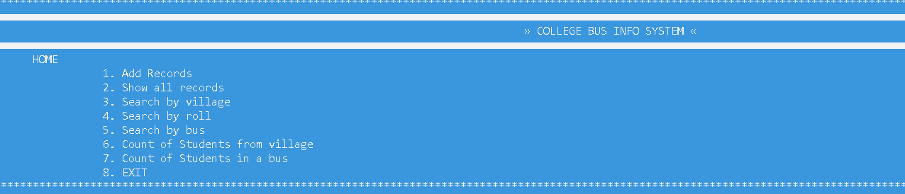

1. **Add Records**

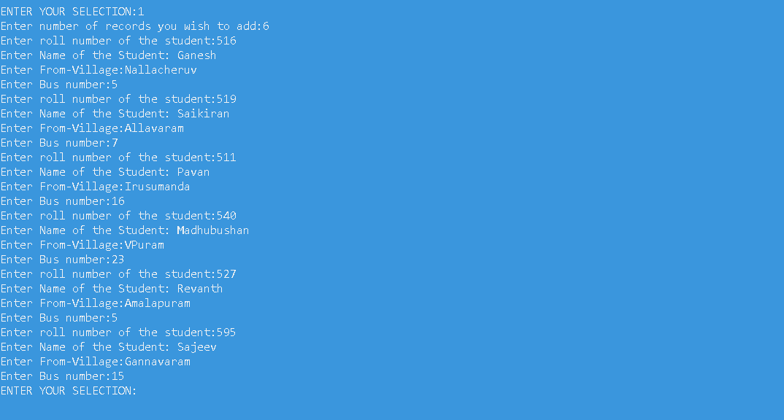After selecting the first option user will be asked the number of records he wishes to enter. The following figure shows the “Add Records” section

1. **Show all records:**

The next option available to the user is “Show all Records”. This displays all the records, that user entered. 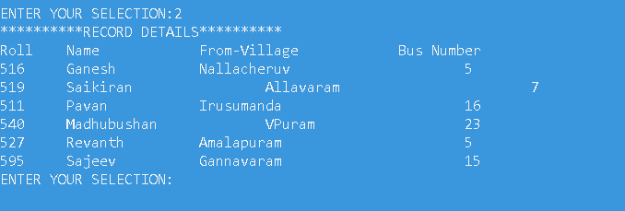

1. **Search by Village:**

Here user enters a village name and the program displays the student transport details from that village.

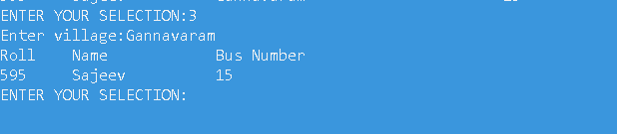

1. **Search by roll:**

The user enters the roll number of a student and gets the Transport details of that particular student.



**5. Search by bus number:**

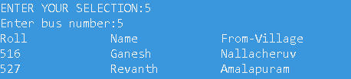Here user enters the bus number and gets the student-transport details of that bus.

1. **Count of Students from a village:**

Here user enters a village name and gets the total count of students from that village.

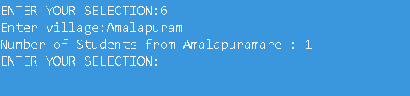

1. **Count of students from a Bus:**

The total count of students from a certain bus can be retrieved using this option.

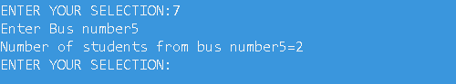

**8.Exit:**

This makes the process end.



**Future Work:**

**Database Connectivity:**

To store the data permanently, a database need to be connected with this console application.

**Desktop Application:**

Desktop Application will be more realistic and more user friendly. This console applications needs a GUI development to design a Desktop Application

**References:**

[1] Web based Student Information Management System – scribd.com